FEIC NSI beam pattern measuring system acceptance tests

FEND-40.xx.xx.xx-0xx-A-xxx

Version: A

Status: (Draft)

2008-June-xx

Prepared By:
Name(s) and Signature(s) | Organization | Date
G.A.Ediss  R. Williams | NRAO | 2008-June-xx
Approved By:
Name and Signature | Organization | Date
Released By:
Name and Signature | Organization | Date

Change Record

Version | Date | Affected Section(s) | Change Request # | Reason/Initiation/Remarks
A | 2008-06-xx | ALL | - | Initial version

Table of Contents

1.0 Introduction 4
1.1 Reference Documents 4
1.2 Abbreviations and Acronyms 5
2.0 Initial checks 6
3.0 Acceptance tests 7
3.1. Alignment of NSI scanner to a mounted cryostat. 7
3.2. Measurement of planarity at various tilt angles. 9
3.2.1. Loading of new planarity matrix and confirmation. 13
3.2.2. Example of data. 13
3.3. Vibration of frame due to cold head operation. 16
3.3.1. Example of data. 16
3.4. Motion of scanner relative to FESS. 20
3.4.1. Example of data. 20
3.5. Repeated measurement of window centers. 22
3.5.1. Example of data. 22
3.6. Check of z step 23
3.6.1. Example of data. 23
3.7. Confirmation of the return to scan center point. 24
3.8. Measurement of beam center with time. 24
3.8.1. Example of data. 25
4.0 Conclusion 26

1.0 Introduction

This document reports on the NSI beam scanner tests, which shall be made for acceptance after delivery.
The tests to be made, in order, are:-
Alignment of NSI scanner to a mounted cryostat.
Measurement of planarity at various tilt angles, loading of new planarity matrix and confirmation that new planarity is corrected.
Vibration of frame due to cold head operation.
Motion of scanner relative to FESS
Repeated measurement of window centers for all bands.
Check of z step when making two scans to remove reflections.
Confirmation of the return to scan center point after a number of scans about a beam.
Measurement of beam center with time.

The three documents given in the RD list are of measurements made on the initial NSI scanner delivered to the NA FEIC and are included for reference, and it indicate some of the problems encountered with the first scanner.

Reference Documents

The following documents contain additional information and are referenced in this document.

Reference | Document Title | Date | Document ID
[RD1] | Alignment of NSI scanner to FESS/cryostat. | 2007-11-02 | FEND-40.09.07.00-071-A-REP
[RD2] | NA FEIC laser interferometer measurements of beam scanner and FESS. | 2007-10-15 | FEND-40.09.03.00-050-A-REP
[RD3] | NA FEIC beam scanner displacement with tilt. | 2007-07-02 | FEND-40.09.03.00-043-A-REP
[RD4] | Procedure Used for Calculating Z Offsets for NSI Beam Scanner | 2007-10-22 | FEND-40.09.07.00-070-A-REP
[RD5] | Procedure for calculating and collecting PAI data for beam patterns | 2008-03-10 | FEND-40.00.00.00-123-A-PRO

Abbreviations and Acronyms

ALMA Atacama Large Millimeter Array
FEIC Front End Integration Center
FEND Front END
FESS Front End Support Structure
FETMS Front End Test and Measurement System
IF Intermediate Frequency
NA North American
NSI Nearfield Systems Inc.
RD Reference Document
VNA Vector Network Analyzer

Initial checks

Upon receipt of the NSI scanner and confirming that there has been no transport damage, it shall be mounted on the three mounting points of the FESS. All mounting bolts on the scanner will be torqued and marked to enable any future movement to be monitored. This shall normally take place in the presence of an engineer from NSI. The motor controller, NSI control computer and the VNA shall be connected and the software shall be exercised to prove that the scanner can be controlled and that the scan data from the VNA can be read.

A cryostat shall then be attached to the FESS – to ensure the safety of the cryostat, especially the windows it should not be mounted prior to the scanner. The scanner weighs over 50 Kg and requires 3 people to mount safely. Also when mounting the connecting bolts these could be dropped and damage a window.

Several of the tests to be performed require the use of an operating receiver. At that point all the necessary equipment to operate a receiver (power supply, monitor and control, control computer, etc.) shall be required.

Acceptance tests

Alignment of NSI scanner to a mounted cryostat.

Equipment required
Faro Laser scanner with control computer and corner cube reflector.

Setup

Clean corner cube - carefully.
Set up laser tracker – Run start up checks in FARO utilities program, initialize, then home.
Set tilt table EL = 0.
Index NSI scanner if needed – insure cold load scanner is fully to left and has no components protruding into NSI scanner movement area.
Move scanner to X = -0.3 m.
Move Cold load Scanner 100m to Right (looking at top of cryostat from subreflector).
In FARO utilities program
Connect
Ok
Measure pad
Setup
Sample/point 500
Ok
Close
Tracker pad
Set distance mode
Distance measurement set to Interferometer set by ADM.
Ok
Close (top right box)
Close

In FARO CAM2 program – File-preferences-scan measurements set to NO scanning
Remove FARO puck from NSI scanner
File < preferences – delete all old data (except device position)
In NSI program set planarity correction OFF

Measure

Measure plane (6 points on the 3 FESS ears).
Insert to insert each point
Home to finish
OK – plane 001
Esc

Measure – line – 2D line
OK to select plane
Measure 4 points from –x to +x along center of cryostat
Insert
Lift off, press home line 001
OK

Repeat for Y axis
Lift off, press home line 002
OK
Esc

Construct – Coordinate system – line/line
Change X line to line 001
OK
OK

Alignment – CAD – part
OK
OK

Measure – line – 2D along X arm of laser scanner
Select plane – OK
4 – 6 points insert each point
Lift off, press Home line 003
OK
Esc

Dimension – Angle – line line
Select line 001
Select line 003
OK
Angle = 0.1067 (example)
OK

Result is OK if less than ± 0.1° from 90 degrees.

If not, set table to 90°, loosen bolts holding scanner – move – reset bolts and move tilt table to 0° and re-measure from beginning.
Continue until angle <±0.01° from 90 degrees.

Move cold load scanner to max x position
Index NSI scanner (if not previously done) set z=0.08 – find center of cryostat – put paper with mm graduations at center of the cryostat; put laser (with no tilt angle) on NSI scanner measure offsets at (0,0) point (example x = +2mm y = +2mm)
Move scanner to set zero –2 mm in x and y

Measurement of planarity at various tilt angles.

Equipment required
Faro Laser scanner with control computer and corner cube reflector with puck.

setup

Put FARO puck on scanner.
Set tilt table to 45°.
If not already done
Move scanner to X = -0.3 m.
Move Cold load Scanner 100m to Right (looking at top of cryostat).

(What follows is from Chapter 24 in Laser Scanner Book).

Measuring and Creating an Alignment

- From the MEASURE menu, select PLANE.
- Measure the plane on the top of the plate. (6 points on 3 FESS ears)
  - Take points on the top of the plate by pressing the INSERT key.
  - Pull up off the surface and press the HOME key.
- Take a look at the results.
  - Label = PLANE002.
  - Click OK to accept the results.
- From the MEASURE menu, select LINE < 2D LINE.
- The SELECT PLANE dialog appears.
  - Select a Plane = M_PLANE002. This will be the plane to which the points are projected.
  - Offset = 0.
  - Click OK to accept the results.
  - ESC
- Move cold load scanner fully to the right – so cannot collide.
- Measure the line. Measure < line < 2D
  - Take the three or four points from the -x end towards the +x by pressing the INSERT key. Move the NSI scanner to Y=-0.35, set x=-.35 move in 0.1 steps to +0.35, measuring each point
  - Pull away from the surface and press the HOME key.
- Take a look at the results.
  - Label = LINE004.
  - Click OK to accept the results.
- Continue with the command
  - Measure a line from the -y end towards the +y by pressing the INSERT key. Move the NSI scanner to x=-0.35, set y=-.30 move in 0.1 steps to +0.30, measuring each point
  - Pull away from the surface and press the HOME key.
- Take a look at the results.
  - Label = LINE005.
  - Click OK to accept the results.
  - ESC
- From the CONSTRUCT menu, select COORDINATE SYSTEM < LINE/LINE.
- Now that you have enough features to define a coordinate system, construct a Line/Line Intersection coordinate system.
- From the CONSTRUCT menu, select COORDINATE SYSTEM < LINE/LINE.
  - Select a Plane = M_PLANE002.
  - Line Defined X-Axis = M_LINE004.
  - Select a Line = M_LINE005.
  - CONSTRUCTED radio button should be on.
  - Click OK to create the coordinate system.
  - Click OK to accept the coordinate system.

CAD=Part

- From the ALIGNMENT menu, select CAD=PART.
- Measured Coordinate System = C_COORDSYS002.
- Nominal Coordinate System = *WORLD*.
- Scale Option = None.
- Click OK to create the Alignment.
- Click OK to accept the alignment.

Save the Measurements

- From the FILE menu, select SAVE AS.
- The SAVE AS dialog box appears.
- File name = planarity<date>.
- Save as type = CAM2 Measure Document (*.fce).
- Click SAVE.

Scan Measurement Preference

  - From the FILE menu, select PREFERENCES.
  - Select SCAN MEASUREMENT.
  - Type of Scanning = Start/Pause Scan With Trigger.
  - Maximum Distance = 900
  - Minimum Distance = 2.0.
  - Click OK.
  - From the FILE menu, select PREFERENCES.
  - select miscellaneous
- set Save scan lines as features to yes
- ok

Freehand Scanning (2D)

- From the MEASURE menu, select SCAN < FREEHAND.
- Type = 2D Freehand.
- Chordal = unchecked.
- Minimum Distance = 2.0.
- Save As = Open Polylines.
- Click OK.
- The SELECT PLANE dialog appears.
- Select a Plane = -YZ_C_COORDSYS002. This will be the plane to which the points are projected.
- Offset = 0.
- Click OK.
NOTE: The offset of 0 mm will create a plane parallel to the YZ plane at X = 0 mm. This will be at the edge of the curved surface.
- Place the SMR on the upper part of the surface.
  - Move NSI scanner to y=-0.3 x=-0,35, run to x=0.35
- Press the INSERT key to begin scanning.
- Move the SMR across the surface contour.
- Press the INSERT key to pause the scan.
- Press the HOME key to end the scan.

- Save the scan data.
  - To keep the scan data, press the INSERT key (or click on yes).
  - To discard the scan data, press the HOME key.
  - ok

Parallel Lock Planes

- From the MEASURE menu, select SCAN < PARALLEL LOCK PLANES.
- Increment = 10.0 (0.50 in).
- Number of Planes = 700.
- Minimum Distance = 0.5 (0.05 in).
- Save As = Open Polylines.
- Click OK.
- The SELECT PLANE dialog appears.
- Select a Plane = -YZ_C_COORDSYS001. This will be the plane to which the points are projected, Move NSI scanner to y=-0.3 x=-0,35, run to x=0.35, press INSERT at start of movement.
- If measured automatically – ESC and set NSI remote, redo 1, 2 set scan running, when get to start position (goes to 0,0 first) press INSERT key and continue.
- If did not measure automatically redo 1, 2 but choose another plane. Repeat until find correct plane, and measures automatically
- Offset = 0.
- Click OK.
- Scan the surface, select plane determined from 2 above.
- Press the INSERT key to begin scanning.
- Move the SMR across the surface contour.
- Press the INSERT key to pause the scan.
- Press the HOME key to end the scan (bell rings).
- WAIT for data to be manipulated
- Save the scan data.
- To keep the scan data, press the INSERT key.
- To discard the scan data, press the HOME key.
- Press insert to save each line.

To look at data

File-review features set to look at readings

Highlight first line, SHIFT END, CNTRL C go to data file CNTRL V enter
Repeat for each line
Put data into text file and transfer to the procedure given in [RD4] for analysis

Loading of new planarity matrix and confirmation.

Measure the planarity data (as given in section 3.2) at tilt table angles 0, 45 and 90 degrees. Then use the procedure given in [RD4] to determine the new planarity matrix. Enter this matrix in the NSI controller computer. Then re-measure at tilt table angle 45. The final planarity should be better than +/- 200 microns over the 750mm scan range in both x and y. If not check for problems and repeat from start of section 3.2 .

Example of data.

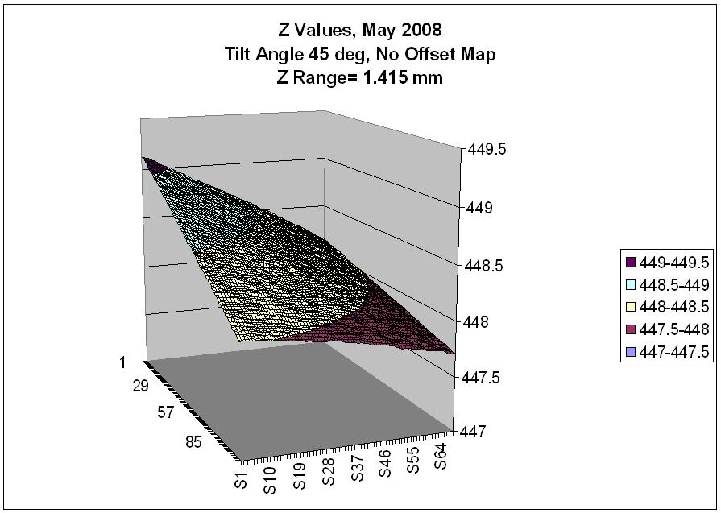
Figure 1 Planarity data with no correction.

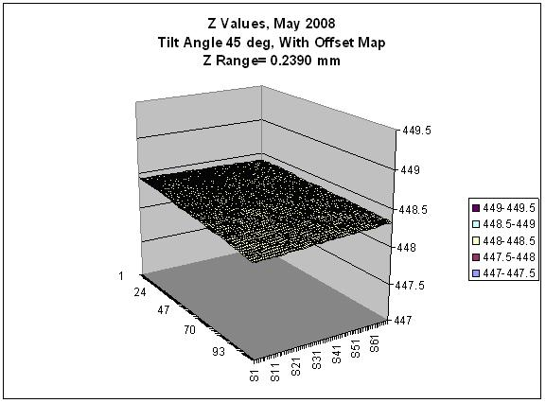
Figure 2 Planarity data with new offsets loaded.

Example of planarity table

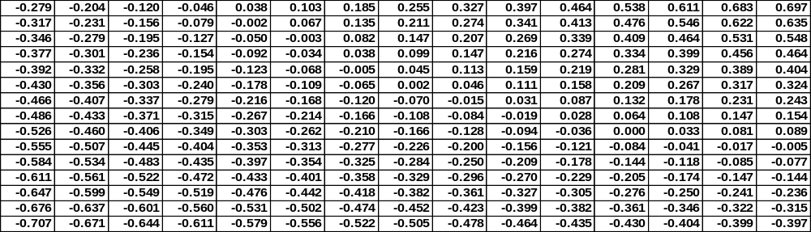

Vibration of frame due to cold head operation.

Equipment required
Faro Laser scanner with control computer and corner cube reflector.

To enable the measurement of the cold head motion, which should have a period of 1 second (50 Hz drive) measurements are made every 25 msecs of the position of the stage relative to the global coordinate system.

Example of data.

In order to determine if vibrations due to the cold head were causing any problems with the measurements, the position of the NSI scanner Z stage platen (to which the signal sources are mounted) was measured relative to the global co-ordinate system of the interferometer laser scanner. Note that the measurement accuracy of the laser scanner in this mode is given as 2 microns in Z and 11 microns in X and Y, with resolutions of 0.158 microns and 0.5 microns respectively.

Figure 3 to Figure 5 show the measured movement of the NSI stage platen with time, measurements were made every 25 msecs to enable the measurement of the cold head motion, which should have a period of 1 second (50 Hz drive). Figure 6 to Figure 8 show a detailed section of 10 seconds. No movement of the stage can be seen within the measurement accuracy of the laser system at the measurement distance involved (approx 0.5 meter).

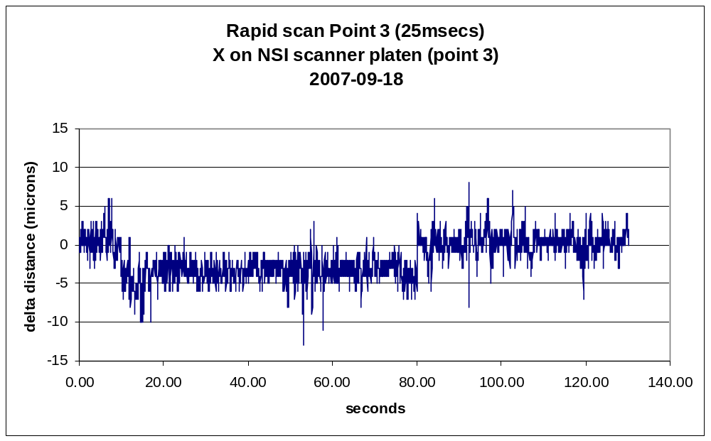
Figure 3 NSI scanner motion in x.

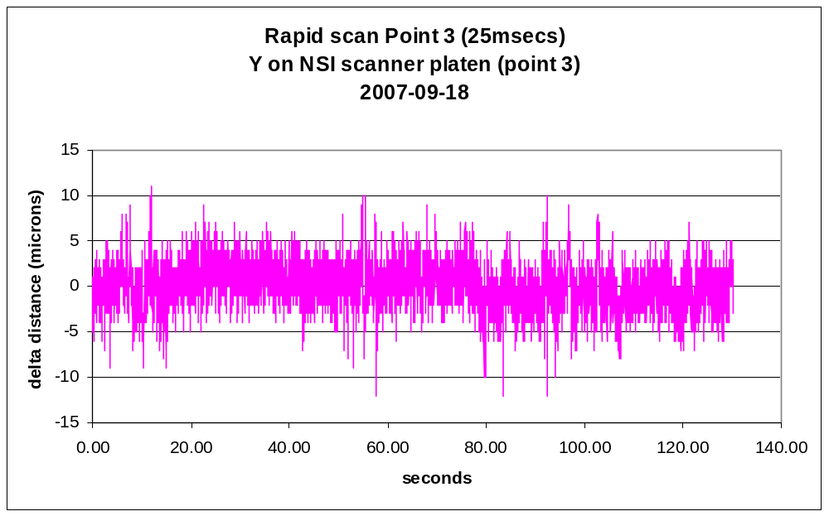
Figure 4 NSI scanner motion in y.

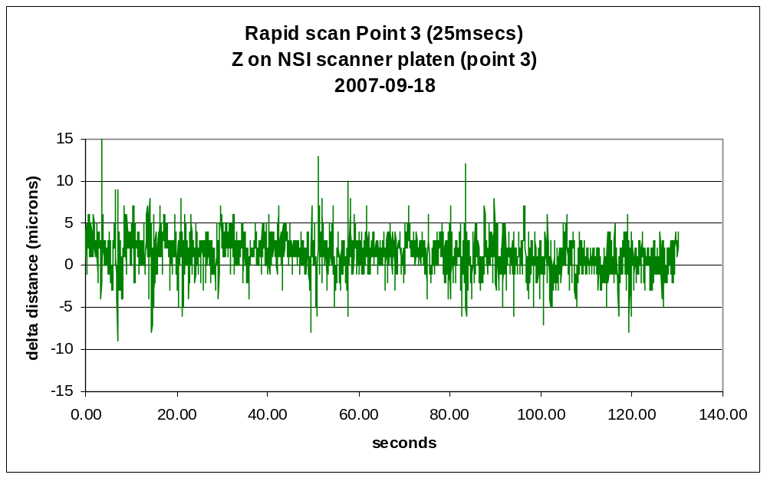
Figure 5 NSI scanner motion in z.

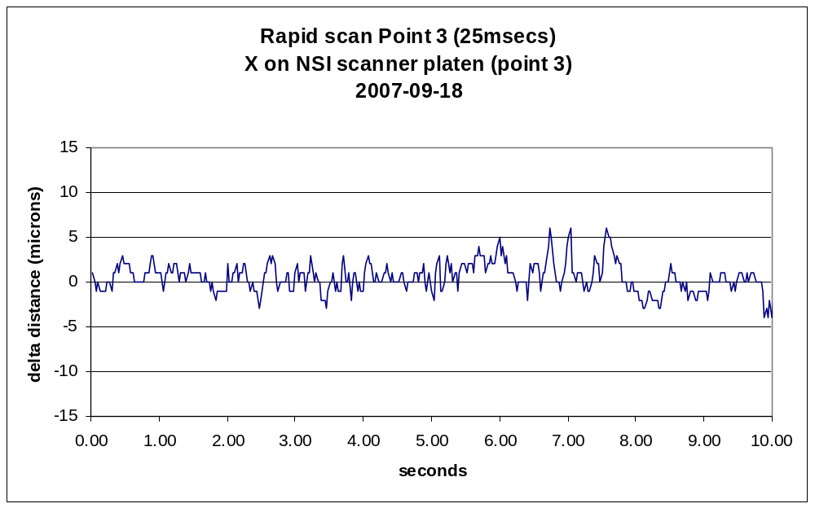
Figure 6 NSI scanner motion in x – detail.

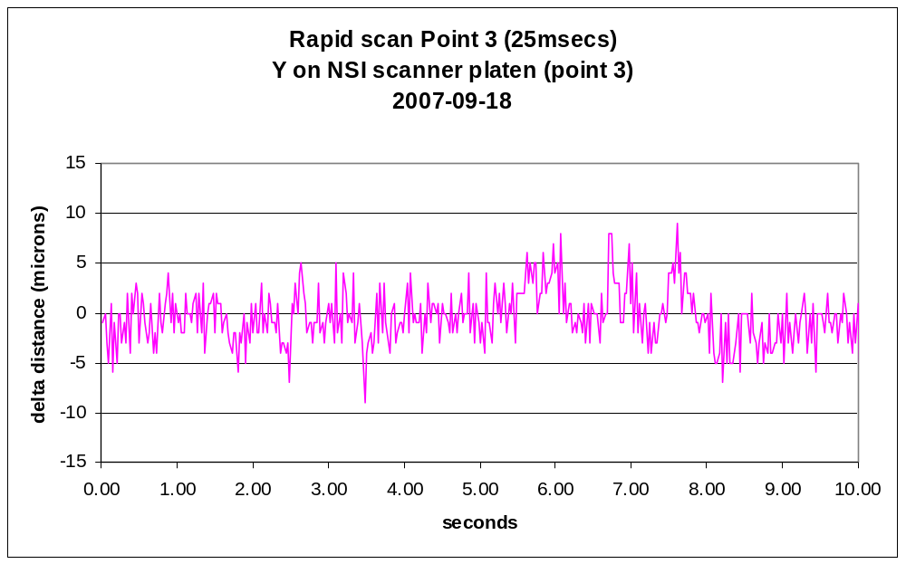
Figure 7 NSI scanner motion in y – detail.

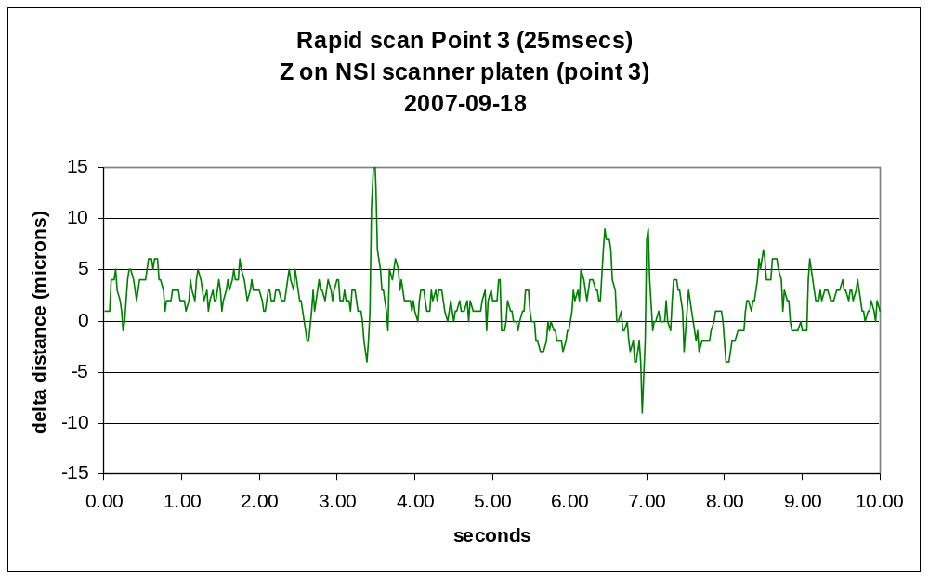
Figure 8 NSI scanner motion in z – detail.

Motion of scanner relative to FESS.

Equipment required
Faro Laser scanner with control computer and corner cube reflector and puck.

A corner cube reflector is mounted on the scanner platen. Measurements of the position are made over 18 hours. The Tilt table is tilted from 0 to 90 degrees, held there for 1.5 hours and then returned to 0 degrees, at which point the measurements are started. Similar measurements can be made of a point on the cryostat (near to the band 1 window), and should give very similar results

Example of data.

The black lines are polynomial fits to the data to give general trends – the equations for these lines are given in the figures.

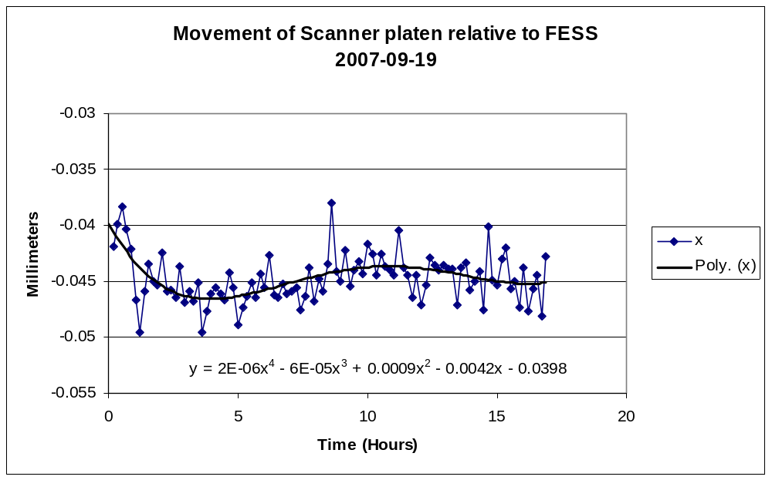
Figure 9

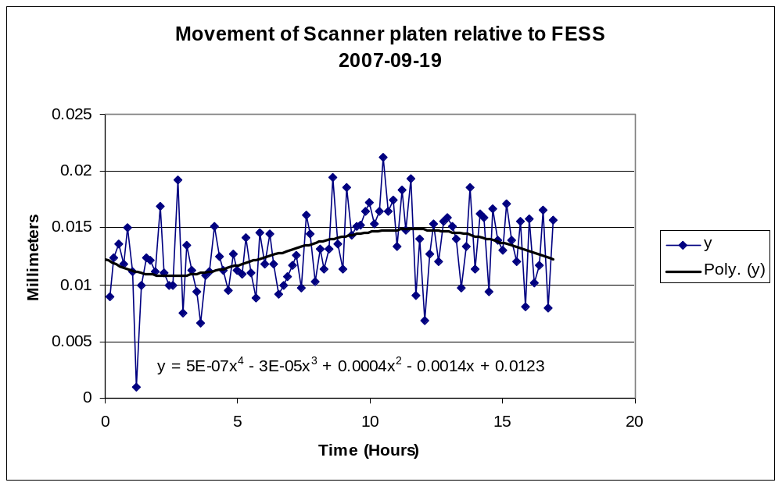
Figure 10

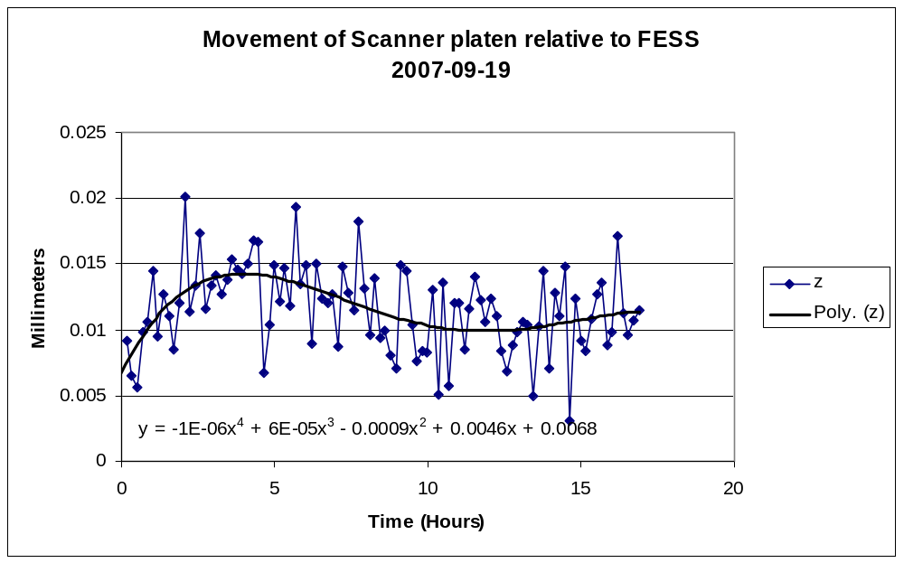
Figure 11

Repeated measurement of window centers.

Equipment required
Faro Laser scanner with control computer and corner cube reflector.

After alignment the NSI scanner is driven to the center points of the 10 optical beams and the x, y positions are measured with the FARO scanner. Figures 1 and 2 give the error (commanded – actual positions) in one axis as a function of the other axis commanded position, after alignment. These figures show that the x and y axes are aligned to approximately 150 microns over a distance of 300 mm (0.5 milli radians), which is acceptable for the measurement of the beam angle to 6 milli radians as required. The measurements have a repeatability of +/- 75 microns. The black lines are a linear fit to the data (equation given in plot). The repeatability is a combination of the NSI scanner repeatability and the x and y accuracies of the FARO scanner, which are approximately 20 microns in these directions (substantially better in the Z direction and ignored).

Example of data.

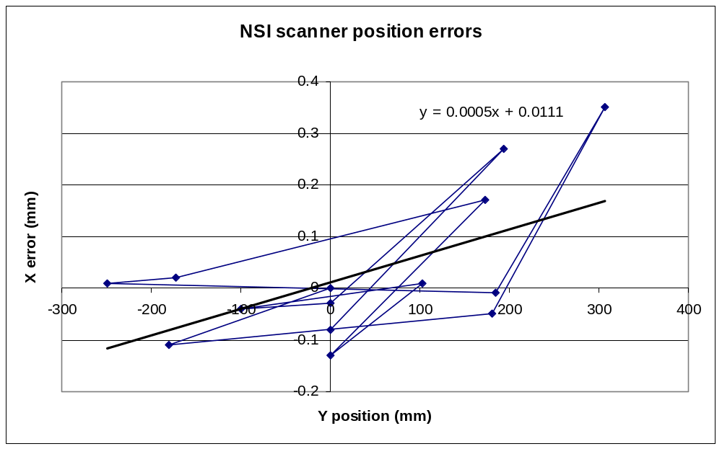
Figure 12 NSI scanner x error versus y position.

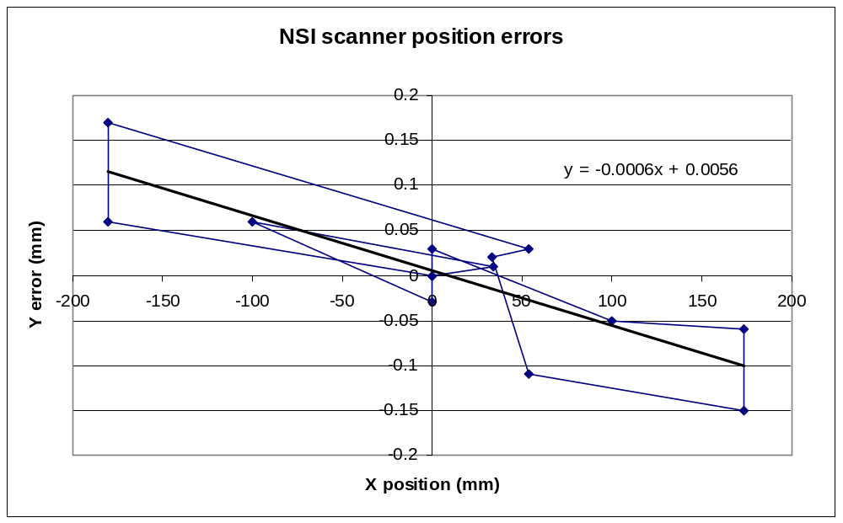
Figure 13 NSI scanner y error versus x position.

Check of z step

Equipment required
Faro Laser scanner with control computer and corner cube reflector.

Measure planarity as given in section 3.2 at one tilt table angle. But only measure over band 9 beam area. Beam center x= 0.001, y= -0.103, scan widths x= 0.075, y= 0.075. In parallel lock planes set increment to 1.0 (not 10.0). Do a scan at z = 0.08 m, save data. Then do a scan at z = 0.08118 m and save this data. In an Excell spread sheet plot the difference in z positions measured and confirm delta is 118 microns +/- 10 microns.

Example of data.

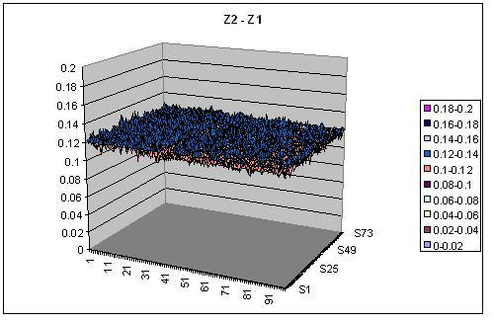
Figure 14 Z2-Z1

Confirmation of the return to scan center point.

Equipment required

Faro Laser scanner with control computer and corner cube reflector and puck.

Measure the x, y, and z position of the NSI scanner when at the center of the band 9 scan. Make 4 scans of the beam, the VNA need not be connected as the NSI scanner data will not be used. At the end re-measure the x, y, and z position. The difference should be within the measurement accuracy of the FARO scanner (approximately +/-30 microns in each direction).

Measurement of beam center with time.

Equipment required

Fully operating front end.

Use the NSI scanner to make a series of 10 scans of any operating beam. Determine the beam center position [RD5]. Check that there is no variation of beam center position with time. Care in mounting the cables to the transmitter is required as this may affect the result.

Example of data.

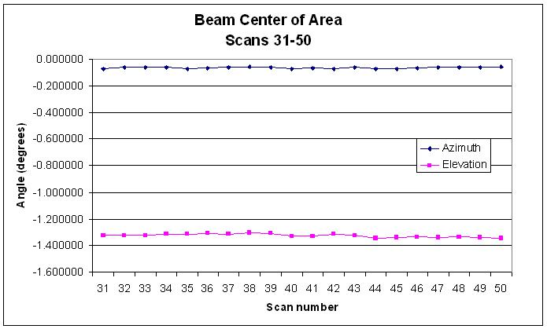
Figure 15

Conclusion

The series of tests to be performed on the NSI scanner prior to acceptance have been given with examples of data taken on the initial scanner at the NA FEIC.

Note default is 2000 = 2 seconds
Wait after insert for data to be taken – click sounds when done

